LDC Name: Roscommon LEADER Partnership
Lot Number: Roscommon County (30-1)
Title of Case Study: Roscommon Responds
Thematic Area: Engagement Strategies with SICAP Target Groups/Communities

Target Group: The Unemployed and Self Employed, People with Disabilities, Low Income Households, Refugees and Older and Vulnerable target groups
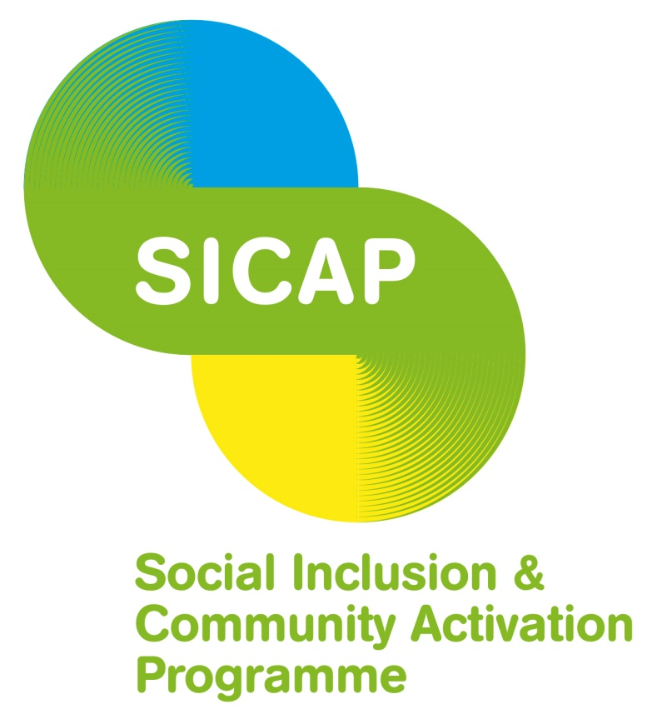
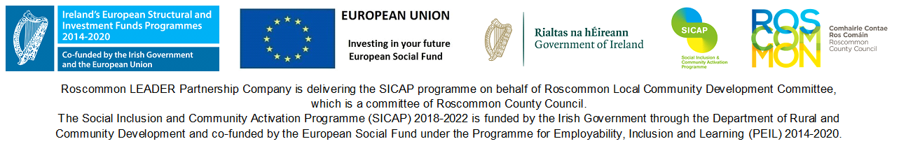
The purpose of this Case Study is to present the various responses employed by the SICAP team in Roscommon LEADER Partnership during Covid-19. The case study will present details on how the programme facilitated the engagement and inclusion of a number of SICAP target groups during the global pandemic, it will include details on engagement strategies for the Unemployed and Self Employed, People with Disabilities, Low Income Households, Refugees and Older and Vulnerable target groups.
The case study explores engagement across both Goal 1 and Goal 2 of the Social Inclusion and Community Activation Programme and illustrates the different measures taken to encourage participation of those who were most socially isolated. It also presents a picture of the collaborative responses used to ensure ongoing support was provided to those most socially vulnerable.
The case study is divided into sections that cover the background, actions, interventions, and related outcomes and lessons learnt. It is presented as a sample of activities under Goal 1 and Goal 2 separately for ease of reading.

Goal 1 Engaging Older People, the most Vulnerable, and People with Disabilities

Background, Actions, Interventions, and Outcomes
Roscommon Responds a SICAP supported initiative to meet the needs of Older People and Vulnerable began as a response to the Covid-19 Crisis. Roscommon was quick to respond the initiative first began on 23rd March 2020.
This strength and depth of the on the ground presence of Roscommon LEADER Partnership coupled with the knowledge and supports available through the Social Inclusion and Community Activation Programme made it the ideal place to begin the response to the crisis.
Roscommon is a large County with a diverse population, much of the population is older, many living outside the main urban settings, without access to transport or transport routes. There are 10,743 people over the age of 65 years in Roscommon, of which 1,371 are 85 years and older. The population of older people in Roscommon is 2% higher than the state average. There are 9,313 people with disabilities in the County; this figure is almost 1% higher than the state figure. There is a significant population living alone over the age of 70 years and needing to cocoon.
Roscommon Responds operated on many levels from practical levels of delivering shopping, and medications to expanding meals on wheels and calls to older people through Roscommon Friendly Call Service. SICAP took a leading role in Volunteer Recruitment.
There is no Volunteer Centre in County Roscommon, on a request from the Department of Rural and Community Development, SICAP in Roscommon agreed to take on this role. It involved promoting and filling roles requirement to deal with Covid-19. This was a time consuming role, however the SICAP team in Roscommon LEADER Partnership were happy to fulfil the role and ensure that those services that needed support from volunteers were provided with a service. SICAP has been working hard to support all of these initiatives through support with writing role descriptions, screening process, advice and guidance on vetting, the provision of up to date information relating to covid-19 procedures and protocols. SICAP provided this support to groups and also to the Roscommon Community Response Forum through active participation at the meetings. SICAP worked hard to communicate the need for volunteers, using local press, and social media as well as existing networks to promote the campaign. We also promoted volunteer from home roles to engage some of those who registered but were not engaged in any physical volunteering activity.
The SICAP team were also keenly aware that for many the pandemic had a more isolating impact than it had on others. SICAP began very early on to mobilise groups who had to cocoon and were extra vulnerable due to health and age related conditions. SICAP placed an extra emphasis on supporting Older People and People with Disabilities.
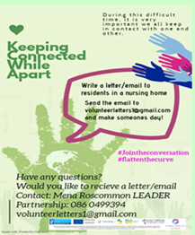
One such example was the Letters of Hope Project jointly established between SICAP and Roscommon VIS where volunteers were recruited to pen “Letters of Hope” for residents in Nursing Homes who were unable to have visitors due to covid-19 restrictions. Ten Nursing Homes across the County participated and the feedback has been amazing. A further step from this was the development of a book of the letters, which will act as a Social History of Roscommon during covid-19; this book was funded by the Department of Rural and Community Development under the VIS, co-ordinated by SICAP.
SICAP set out to ensure where possible the groups of older people and people with disabilities could engage using technology. Groups of older people were supported to download and familiarise themselves with zoom, this was often done on a one to one basis and took time however it ensured older people were connected. Older People’s groups have been supported to meet regularly over zoom. These meetings have supported the development of information and resource packs for older people. Many of the Older People who were cocooning were worried about the impact of cocooning on the mental health of older people, so we arranged training on “Communicating the Cause” to support them to express their feelings.
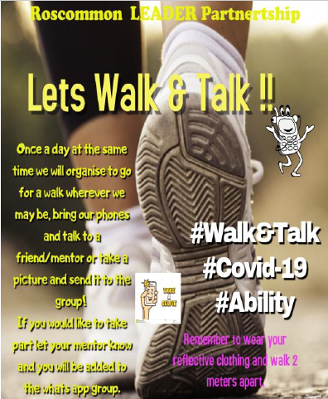
In order to support people with disabilities to continue to engage with and participate on SICAP initiatives we worked with the Ability Programme to establish a Walk and Talk Group. Daily people with disabilities engage via What’s App uploading photos and updates of their walks, the purpose of the group is provide a space for peer support and to encourage participation and connectedness and also mental and physical wellbeing during this pandemic. The feedback has been very positive from both participants and their parents and the SICAP team together with the Ability Team is working with participants to develop a booklet of photographs detailing their journey of the pandemic.
Group development and capacity building remained essential SICAP supports over the last number of months. SICAP has worked tirelessly to support groups as the pandemic evolved offering training to groups and social enterprises over the medium of zoom. For many groups to participate we needed to support them with technological issues, they how to of what’s app, zoom, Microsoft teams, it was a new challenge for our groups but one they rose to. We offered training in topics such as Supporting People with Disabilities return to Work, Risk Management and Infection Prevention and Control.
SICAP continues to meet the needs of vulnerable and older people in our Communities who as a result of the ongoing pandemic need to be able to access affordable meals. SICAP is working with an existing CSP to develop a Meals on Wheels model suitable for Mid and South Roscommon in partnership with Roscommon County Council, Roscommon Homecare Services and other key stakeholders. These needs came to the fore because of the pandemic and SICAP is ideally placed to support local communities to address these felt and expressed needs through guidance, advocacy, business plan development, support with funding applications and funding to support engineering and planning. This is clearly demonstrates how SICAP can identify a need felt by one of its target groups locally and can work in collaboration with all the key stakeholders to develop a response to this need to the benefit of the SICAP clients.

These interventions and developments have resulted in the following outputs over the last 6 months:
Total to date
- Cases related to collection and delivery of food, essential household items fuel , medicines in line with guidelines | 806
- Cases related to social isolation, supports, engagement | 505
- Friendly Call Service Calls | 1326
- Cases related to meals and their delivery | 2638
- Keadue Social Services Meals on Wheels | 974
- Volunteers Recruited from March to September 2020 | 181
- Community Groups/Organisations Registered on I-Vol March  To September 2020 | 29
- Activity Packs for Older People | 135
- Information Packs for Older People, Travellers and New Communities | 274
- Activity Packs for People with Disabilities | 150
- Walk and Talk Group Participants | 28
- Nursing Home Volunteers | 32
- Interventions with LCGs since March | 285
- Interventions with Social Enterprise since April | 30

Group Development, Capacity Building and Engagement
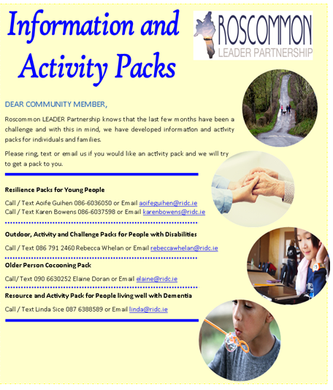
SICAP’s response during the pandemic has continued to build capacity of local community group and also continue to promote Community Engagement and build stronger Communities. These interventions, actions and initiatives by SICAP have ensured the most vulnerable in County Roscommon have continued to live well despite the pandemic. It has ensured that at the most basic level with the support from SICAP volunteers and groups’ capacities were built to deliver groceries, meals, medications, animal feed and more to those who were cocooning. It has ensured that Older People were upskilled and engaged using technology to continue to have a voice, to influence change and advocate for their peers resulting in the development of robust information and activity packs for those living alone without access to broadband.
It has also ensured that at the most basic of levels people feel connected through zoom meetings, through the letter writing campaign to Nursing Homes and through the Walk and Talk Group for People with disabilities. This engagement has provided a new sense of connectedness and a greater level of engagement for those who were very vulnerable and isolated during the height of the pandemic. As a result of SICAP Staff support and training on zoom and what’s app some of our older people have reported using zoom to engage with other groups in their local community. They have also indicated that they have used it to “meet” family who could not visit due to restrictions. Parents have acknowledged that the Walk and Talk group has provided their child with a sense of purpose that they lacked as all services were otherwise closed for them.
One Older Person said “…feel thought of” on receiving the activity pack.
One of the most crucial roles SICAP could and did play in Roscommon was ensuring connectivity and inclusion in an otherwise isolating and lonely environment for so many of our vulnerable.

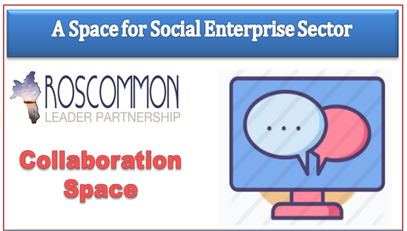
Support to Social Enterprises
Another critical role SICAP played and continues to play during the pandemic is the continued support to Social Enterprises. Ongoing and practical supports are essential to ensure that social enterprises can continue to survive and meet local needs whilst also supporting them to meet SICAP outcomes. It now more than ever important to continue to support the economic and community development of our County ensuring the delivery of local services whilst also maintaining employment opportunities for SICAP target groups.

Lessons Learnt

Time and Demands
For the first number of months there was extra time required to meet the demands and need of SICAP, It was difficult to gauge the time requirements and to meet the every changing needs as the scale of the pandemic grew. The needs and priorities changed and it was essential to be flexible and as adaptable as possible. This involved long days, evenings and weekends, however, it was necessary to ensure the appropriate systems and supports were in place. It was also essential to ensure the timely distribution of accurate and relevant information especially to those who were most socially isolated.

Volunteering – The new role for SICAP, Vetting and Roles
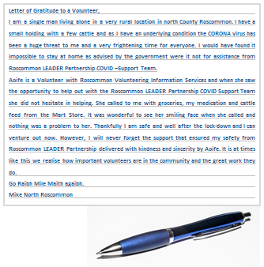
SICAP agreed to bridge the gap as there was no Volunteer Service in the County. This involved an extra role and time requirements. It was taken by SICAP as we realised the necessity, however it was very time consuming and all-encompassing at times.
In terms of the role of SICAP in the supporting the recruitment and placement of Volunteers as we do not have a Volunteer Centre there were a number of challenges. The clarity around whether volunteers for practical roles such as delivering of groceries took some time to establish. There was differing sets of guidance from national bodies and it made the communication of best practice locally a challenge. There were other organisations who were not vetting based on interpretations of the Act. It was a challenge to provide guidance to groups around this topic.
There were many groups who were dormant because of covid-19 so there were more volunteers than roles; there was a challenge to keep those who registered engaged and to ensure they did not feel that they were not valued. Developing initiatives, which could be completed from home such as the Nursing Home and the Buddy System, helped with this.

Use of Technology
Given the age profile of Roscommon and the Age Dependency Ratio there was a significant cohort of Older People and People with underlying conditions, together with high numbers of people with disabilities cocooning in County Roscommon. There was a big challenge to continue to engage these people. It was clear from early on that we needed to embrace technology in order to engage this cohort, but it was equally clear that lack of broadband, lack of devices and a fear of new technology would present as further barriers. We spent significant time working with older people and people with disabilities on a one to one basis to support them to use what’s app and zoom in order for them to remain connected. This was a tiresome and difficult for all concerned at times but most rewarding when we saw a new face on zoom or received a new message in the group what’s app.
Technology and the use of is not the solution for all as the barriers above outline. For some we needed to take up the phone and call or send them information packs. The Friendly Call Service was an invaluable resource at this time, without which many more vulnerable residents in County Roscommon would be very isolated. Roscommon Friendly Call Service is a SICAP led and co-ordinated service which is now in its 12th year of service.

Impact of Cocooning on Wellbeing
Cocooning has had an untold impact on the physical and mental health of many older people and people with disabilities. It is going to be a significant challenge to engage some of these individuals in group settings again. One example is those living with Dementia and their carers. They are so fearful they do not want to leave their homes, yet isolation has a big impact on the lives of those living with Dementia, it has the capacity to leave them even more dependent and isolated. This will be a challenge as the country start to move towards living with Covid-19.

Sense of Achievement and Contribution
Being part of the local response to supporting vulnerable cocooning and supporting volunteers to volunteer safely has provided all of us involved with the delivery of SICAP with a great sense of satisfaction and worth.

Conclusion
These initiatives led by SICAP with the support of volunteers have led to people being able to Stay Well at Home. They have ensured that our most vulnerable are connected and are receiving their groceries, meals and medications. It has also resulted in them receiving timely, appropriate and accurate information from HSE and Government as well as a range of information on local supports and activity packs. Roscommon Responds has and continues to support those most socially isolated to stay connected.

Goal 2

Background, Actions, Interventions, and Outcomes

Supports to Employers on Safely Returning to Work
Roscommon LEADER Partnership SICAP had planned to lead on the delivery of a Jobs Fair in September 2020 in Roscommon town to support employers in the recruitment of staff and also for job seekers to meet potential employers.

Due to the government restrictions from Covid 19 the needs for employers drastically changed to an urgent requirement for information and training for the safe return to work in June 2020. This need was identified through ongoing and direct contact with employers. SICAP responded to the need by hosting an online webinar named “Covid 19 guidelines for Hospitality Sector.”
As part of registrations, employers were asked what information they needed, and these responses helped guide and shape the presentation. The presentation was directly informed by the Failte Ireland, HPSC and HSE guidelines.
Promotion of the webinar took place using different media including, social media, Eventbrite and direct contact with employers. The webinar was delivered by SICAP staff and there were 15 employers present. There was a significant larger number registered on Eventbrite for the event, however many did not participate on the day. The feedback was very positive and employers who had expressed uncertainty about reopening indicated they had now a much greater depth of knowledge.

Lessons learnt

Post Event Follow- up
Even though the response to Eventbrite was large and each employer was contacted with the link and welcomed, follow on communication may be needed to assess if further supports are needed. The employers on zoom expressed their gratitude and how the training was of a high quality, only one business gave feedback via survey monkey. In the future this could be overcome by an agreement to completing survey monkey on registration.

The importance of knowing the Needs
The learning was also that this was a worthwhile response to support employers in reopening their business and in turn to support their staff. Establishing needs of employers prior to finalising the presentations was an excellent way of ensuring that the presentation meets the requirements of the employers.

Supports for the Self Employed during Covid-19
The arrival of Covid-19 created a major shock for existing and new start-up businesses. It left business promoters in mental and physical isolation. It created major problems in regard to the sustainability and viability of many businesses and posed many challenges for their reopening.The majority of businesses supported under SICAP and the BTWEA/STEA schemes are micro enterprises and were forced to close down due the virus. The SICAP Co-ordinator responded with wide ranging information and supports on grant that would help these businesses get through this very difficult period. Inter agency collaboration was key to the responses provided by SICAP.
Early on in the crisis the SICAP Co-ordinator concentrated energies into getting the right information out to clients in regard to the Covid-19 Emergency Unemployment Payment. Many individuals were advised how to apply for the payment. Application forms were made available for those who could not apply online. Liaison with and signposting to DEASP case officers and LEO staff was frequent during this period. Enterprise clients were also encouraged to seek one to one and group mentoring supports from the SICAP Self Employment and Entrepeneurship Programme. WhatsApp and Zoom calls from the SICAP Co-ordinator played an important part in boosting the morale of its business client base. Clients were also signposted to LEO supports which included trading online vouchers, Business Continuity Grant and also to the Business Restart grants from Roscommon County Council.
Key communication tools to get information out to our enterprise clients was via RLP Newsletters, emails, texts, WhatsApp, Telephone, Zoom, RLP Facebook page.
BTWEA clients were advised and sent information on sectoral guidelines in Health and Safety in regard to reopening their specific businesses. These included documents like the Government Roadmap for Reopening Business, Construction Operational Procedural Guidelines, Failte Ireland Guidelines for Tourism/Hospitality and the Reopening of Hairdressers Guidleines.
The interagency response was central during the period from March to June when RLP collaborated closely with DEASP and Roscommon LEO to ensure the relevant supports and information were provided to SICAPs micro enterprises.
Ongoing contact was also maintained with the unemployed who were planning new business start up. Online training workshops via Zoom were organised by SICAP for new start-ups in Business Planning, Tax/Accounts and Social Media Marketing. These were followed up by one to one mentoring supports. Online tools like Zoom and WhatsApp enabled the SICAP Co-ordinator to continue to prepare applications for the BTWEA/STEA schemes.

Lessons Learnt

Information, Communication, Networking and Collaboration
- The importance of timely and accurate information on the supports and grants available during Covid
- The value of ongoing contact and networking supports with existing SICAP enterprise clients and also with new business start ups through various online communication channels during Covid
- The important role of our online training platform Zoom during Covid
- The value of interagency collaboration with the DEASP and Roscommon LEO during Covid as well as clear signposting information about the services and supports they have on offer

Supports to Low Income Rural Households
Roscommon is a rural county relying heavily on the agriculture, which is one of the main components in our economy. The kernel of farming is a reliance on easy access to trade be it farm based or household based. Through the challenges imposed both by Covid 19 pandemic and by adhering to HSA movement restrictions during lock down and beyond this has a massive impact on farmer market outlets and ultimately left many individuals and household in vulnerable and volatile situation as outlets for trade were restricted. This situation was especially difficult among older farmers as now trade revolved around online platforms and this was new territory for many.
SICAP endeavoured to assist and support individuals and households supporting and training them on how to access and utilise online and social platforms for their own benefit. As part of this, those who had some IT knowledge, Zoom and WhatsApp’s platforms were used to educate and assist the end user in how to utilise the various Apps. The most common platforms used were ‘MartBids.ie’ and Done deal. For the non-liners this simply required ‘someone to do it for them, it meant that a staff member manually set up the App on their device and direction then could be done by phone. Another action that was delivered was showing farm families how to register, complete and maintain their farm safety statement online, this statement is a requirement by Bord Bia for farmers in the scheme to avail of a top up payment for participating. This support was delivered by Zoom.

Lessons Learnt:

I.T. and I.T. Ability and the Impact of I.T. Usage
Challenges with poor internet connections and low IT abilities of some clients proved difficult with delivery. There is a need for continuous opportunities for individuals to upskill on digital skills across different devices.
Another lesson learned was while online engagement was beneficial it also contributed to promoting effects of rural isolation by reducing the need to have face to face contact. Also, the continued need for Interagency Agency Collaboration in delivering such supports going forward in terms of content and delivery.

Children and Family
The arrival of Covid-19 brought fear uncertainty and total shock to families throughout the country. SICAP met with Ballaghaderreen Family Resource Centre to establish if there was anything the we could jointly do to assist these families in any way.
SICAP agreed to update social media on a daily basis with necessary information. It made up information packs that could be collected from a box left outside the door. The intention was to create these packs for one or two weeks but the uptake and demand for them lasted throughout lockdown and into late summer.
The first information pack provide information on mental health, diet, exercise, help line numbers, Covid information and self-care, as well as word searches, colouring pages and pencil both for adults and children.
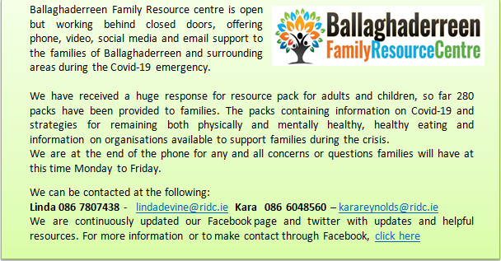
Over the following number of weeks, themes were picked and packs were made up for collection. SICAP and the FRC were asked to assist the families in the EROC Centre (Emergency Reception Orientation Centre) by providing packs in their language for collection every Friday. In total 6,850 packs were collected over Covid lockdown
The cost of food became an issue for some families with children at home all day and some families who were co- parenting now found that the children were with one parent for the whole of lockdown. It became apparent that we needed to establish a food hub. Engaging with local services/agencies this was quickly addressed and food boxes were made up by SICAP. The boxes were packed with essential food items and either delivered or collected from outside the FRC.
In the absence of services opened to the public, SICAP office became a contact point for forms, which were requested and collected from the office. A number of people who had problems with their payments also contact SICAP office where their query was taken and email to the case officer for the Department of Employment Affairs and Social Protection

Lessons Learnt

Access to information, support and essentials
- The importance of timely and accurate information for our clients
- The value of interagency collaboration so the needs of the client can be addressed in a timely manner

Supports to Newly Resettled Syrian Refugees, Roma and undocumented
SICAP was very conscious of the needs of the Syrian Refugees who were newly settled to the County and who had limited English and also who a limited social network. It was also critical to take into account the poor health literacy of this particular target group. Work had begun in 2019 to improve the health literacy of the refugees but was clear that SICAP had to play a significant role in ensuring the wellbeing of this target group once the pandemic hit.
Ongoing contact and support was provided to each of the resettled Syrian Refugees in the County through what’s app video, phone calls and emails. Support advice and guidance was provided on a regular basis and this was also translated in Arabic. A translator was employed who also contacted each of the refugees on a regular basis and discussed in detail in Arabic the restrictions, the health guidelines and good hygiene etiquette. Queries and issues were then dealt with by the SICAP staff to ensure the refugees were availing of all supports and services needed at any given time.
Information was translated into Brazilian and Slovakian to support these communities in relation to covid-19 and in particular to reach out and support those who were undocumented, ensuring they were aware of the right to Health Care and Social Welfare should they contract covid-19.
Ballaghaderreen is home to a number of Slovakian and Roma families who are reluctant to engage with local services so SICAP organised relevant information packs with HSE Covid information in their own language, contact national emergences phone number and local phone numbers. In addition, HSE posters were included as well for their homes. These packs were posted or delivered to twenty families in the town and the surrounding neighbourhood.

Lessons Learnt
Those who do not speak English as a first language are exceptionally vulnerable at a time of crisis. It is not only critical to translate information into other languages it is essential to have an interpreter discuss and support them to identify and key areas of need and where support is required.
Those who are undocumented are living in fear and they fear of losing their job and income impacts on their decision making. It takes a collective effort of the community and key stakeholders to communicate messages in a way that builds trust.

Conclusion
In conclusion, SICAP support was very well received and beneficiaries engaged in actions. They spoke very highly of how positively SICAP impacted on their lives and provided them with the information, support and guidance to manage and continue their lives and businesses, albeit using alternative platforms.

Census 2016
This number would typically be 30 per annum
These packs included Covid-19 Government/ HSE specific information, together with information from across the county of shops and pharmacies delivering supplies and information on wellbeing supports. They also included arts and crafts, puzzles, seeds and treats.

