Roscommon Leader Partnership SICAP Case Study

Theme:
- Engagement Strategies with SICAP Target Groups/Communities
- Collaboration

Goal 2
Submitted by: Roscommon LEADER Partnership

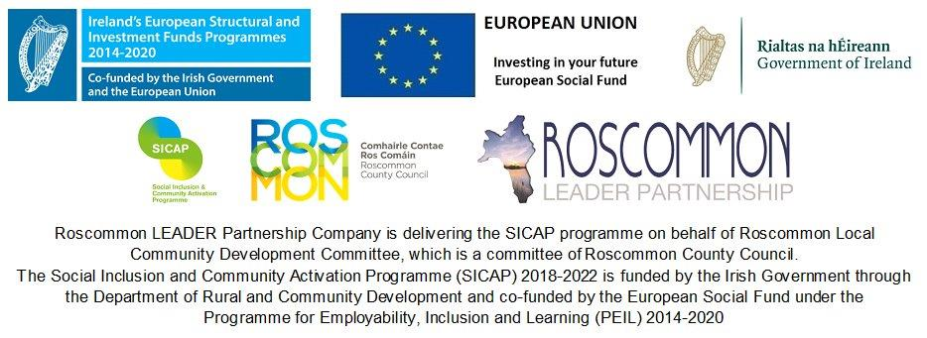

Introduction:
The Case Study presented below was chosen based on the themes identified under:
1: Engagement strategies with SICAP Target groups and Communities.
2: Collaboration as they clearly outline the ongoing work and support that Roscommon LEADER Partnership are engaged upon under SICAP.
This case study will address Options events and Foundation’s Training Programme. It will highlight the success of the innovative Options events and it will include two follow up interviews taken from participants who took part in the Foundations Programme highlighting the positive impacts it has achieved.
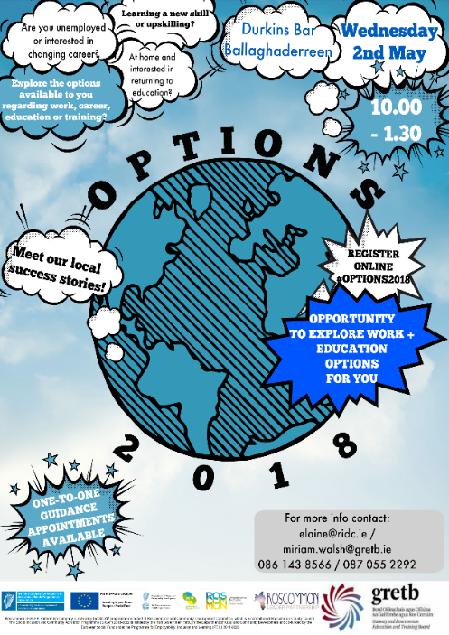
Options was developed through Roscommon Leader Partnership (RLP) collaborating with the Galway/Roscommon Education and Training Board (GRETB) which was known as the Options Working Group. This group was a sub group of the ‘Youth Engagement Multi- Agency Taskforce’. It is supported under the SICAP programme. It developed through a series of interagency meetings where it was established the need to engage with a cohort of NEETS aged 16-24 throughout the County of Roscommon. It came to our attention that in previous times training courses were organised yet there was no engagement from this particular group. RLP and GRETB came together and developed a series of events throughout the county. These events were named ‘Options’. The idea behind this event would be those representatives from RLP, Department of Employment Affairs and Social Protection (DEASP), and the GRETB, along with a number of support agencies in the area would be available to discuss their supports, interventions and training available to the individual as well as further education, apprenticeships, employment options or opportunities. One-to-one appointments with a Guidance Counsellor on the day would also be available as well as one local employer in recruitment mode.

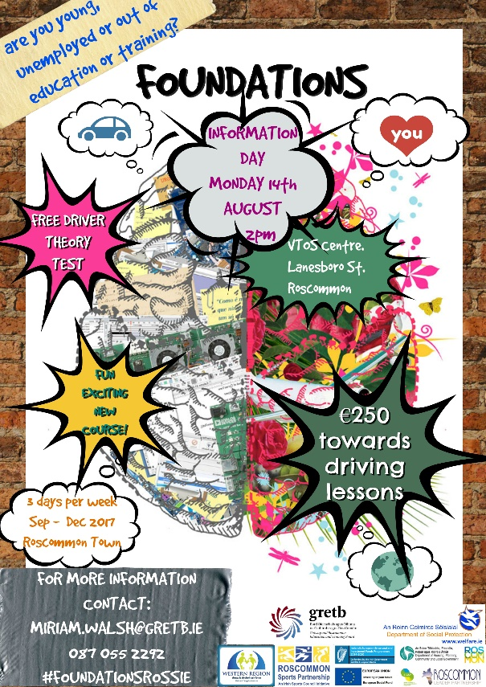
Foundations Programme was established through what originally was the Options Working Group with an added collaboration from the Western Region Drugs Task Force (WRDTF). This group became known as ‘Youth Engagement Multi-Agency Taskforce’. Roscommon Leader Partnership formed this working group and after a number of meetings we received commitment and financial support . The group was made up of local agencies such as Roscommon County Council with an emphasis on town teams, DEASP, AIT & GMIT Colleges, HSE, Foroige, TUSLA and many more. Through consultations it was discovered that there was a significant problem within our NEETS category of low engagement in training and or employment. From having previously held our Options events, we became aware of the high unemployment rate and low engagement of NEETS in disadvantaged areas. Therefore, we developed a training course called ‘Foundations’.
Project description:
The Options events took place in Ballaghaderreen and Roscommon in 2018 and will also take place in Monksland on the 24th of October. The idea of the events is for the youth in the area to meet with SICAP staff to learn of the supports available to them and also to hear stories from guest speakers on an informal non-judgemental way on their career path and what options they took. Some of these speakers were past recipients from SICAP and were very familiar with the path that most of these youths were on. These individuals were met on a one to one where a PAP was completed and guidance and supported offered. Not everyone engaged with this offer. This is where we felt these particular individuals needed more of a support system put in place and were referred to attend an information session in relation to the Foundations programme and their suitability to it which will happen in early 2019.
The target group was identified as the NEETS category primarily for both Options and Foundations. It was aimed at this group as it was felt they were most at risk and most vulnerable, they have varying relations with work, mixed levels of motivation/disaffection, unequal training paths, and unequal family resources. This category was also recognised as a high risk category.
The venues decided on for the Options events were:
- Ballaghaderreen in May
- Roscommon in August
- Monksland in October

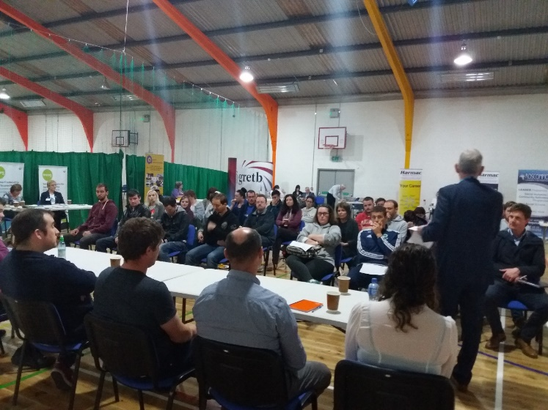
The pillars of success and core elements of the Options events were the ‘Local Champions or role models’ that attended these events on the days. They were once a NEET and could relate to the attendees on the day on an informal and non-judgemental way. We had guest speakers from all walks of life such as a high profile head Chef in a famous hotel who dropped out of school and fell into a life of addiction, but began working as a Kitchen porter and realised there were other options he could take in order to build a career path. Our attendees found the speakers were on the same level and could engage with them easily. We also had a beneficial service or clinic on the days with the GRETB career guidance counsellors who could offer support and information to the attendees and lastly we had an enterprise element on the day where one of our Guest speakers had recently won ‘Young Entrepreneur of the Year’.

Also as part of the 2018 plan we had a follow up to the Foundations programme. We met with the participants in early January and February to update and to see where best we could support the individual. We completed evaluations with the participants and we as a group learned going forward improvements to make to the next programme. Some of the improvements we will make will be to recruit a full time coordinator over the programme as this will add value to it and not take valuable time from the mentors who offer support and guidance daily to the participants. Also we will add a work experience element to it where we will engage with local employers for support. We also carried out interviews with 2 participants from the Foundations programme which you will see on the attachments. We completed these evaluations/questionnaires as part of our tracking system to be able to measure the impact that foundations had and how we could further support them into employment or training.

On completing an evaluation or questionnaire with participants, it has clearly shown an impact was made. 2 of the participants interviewed are both in further Education and are both very happy, one said ‘I wish I could go back to Foundations, it taught me so much that I only realise now. I wouldn’t be doing this course now as I was too shy and had no confidence, now they tell me I am a chatterbox’. This participant has almost completed studying her Level 5 Health Service Skills and has said she always wanted to do something where she was helping someone and now she can. The second participant is now in full time training on an apprenticeship programme in Tiling. He stated that without Foundations ‘I would be still stuck in my old life, getting into bother as I had no routine or no outlook on life’, this made me get up out of bed and do something with my life.

Our findings from meetings with the participants were:
- 2 participants are completing apprenticeships in Athlone training centre.
- 5 participants are engaged in Vocational Training Opportunities Scheme (VTOS) in Roscommon town on Level 4 and Level 5 programmes.
- 3 participants are engaged on a regular basis with mental health services in Roscommon town and are progressing well.

The biggest challenge met with the Foundations Programme was funding and as a result we focused on exploring the funding opportunities, the venue suitability and the staffing costs in order to progress the delivery of another programme.

Time frame of Activities for the Options/Foundations events 2018

January /February | SICAP interventions, supports given to previous Foundation participants
March/April | Preparation began for the first Options event to be held in Ballaghaderreen.  A detailed funding application was written for QCBI through Tusla in order to help with funding for the Foundation’s programme.  Weekly meetings with GRETB re: Options
May | Ballaghaderreen Options Event took place  Weekly meetings with GRETB re: Options
June | Follow up with attendees from the Options event, provide SICAP support were necessary
July | Did not receive funding from QCBI therefore arranged a meeting with task group to explore other funding options for the foundations programme.  SICAP staff member explored the option with LEADER funding.  Preparation began for the second Options event to take place in roscommon In August
August | Task group met with LEADER to discuss funding opportunities for the foundations programme.  Second Options event took place on the 29th of August
September | Follow up with Options attendees  Meeting with Task force group to complete EOI for LEADER for the foundations programme.  Preparation for the third options event to be held in Monksland in October

The venue decided on for Foundations is not confirmed at present however the area we will be working with is chosen as Boyle, Co Roscommon in early 2019.
Good Practice & Challenges:
The Foundations Programme was adapted from the Foundations for Life Programme that was first designed and delivered, under the Social Inclusion and Community Activation Programme (SICAP), by South West Mayo Development Company (SWMDC) and the WRDATF in County Mayo during the spring of 2017.

The Options model was designed and delivered through Roscommon LEADER Partnerships own model and adapted to suit the NEETS category. The addition of the ‘Local Champions or role models’ that attended these events on the days were invaluable as they were once a NEET and could relate to the attendees on the day on an informal and non-judgemental way. We had guest speakers from all walks of life. We also had the quality in the information stands that attended and gave valuable information to each attendee.
The main challenges which we were faced with was funding, staff costs and venue suitability with the foundations programme as a remote, safe and suitable building was needed to successfully benefit this programme.
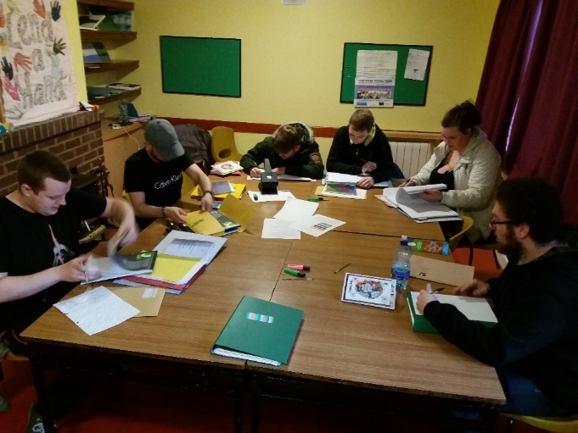
In April 2018 we applied through the QCBI Innovation Fund: Enhancing Children’s and Young People’s Outcomes for a total of €44k in order to secure funding to enhance the foundations programme for 2019, unfortunately we were met with a negative and were not successful in this application.

The next step was to apply through LEADER funding. The task working group meet on a monthly basis to process these funding applications whilst also working behind the scenes in gathering the necessary supporting documentation. We are in the process of completing the EOI application for LEADER funding and also have formed a steering group of funding bodies and stakeholders. The first meeting will take place in early October with this steering group

Staffing Costs.

The purpose of enclosing the staffing cost table below is to highlight the hours/time commitment and resources of staff allocation that went into the delivery of this programme. The delivery of another programme in 2019 will require similar resources.

The working group designed and coordinated the Foundations programme and also delivered the QQI component. The time away from their organisations has a cost implication both in terms of their salaries and also an opportunity cost that relates to other work and projects they could have been assigned to.

Agency | Total off-site Coordination and Planning Hours | Total On-Site Days | Total On-Site Tutoring and Mentoring Hours | Total Hours
RLP | 193 | 15 | 60 | 253
GRETB | 214 | 17 | 68 | 282
WRDATF/SWMDC | 174 | 30 | 120 | 294
WRDATF/GRETB | 252 | 36.5 | 146 | 398
 |  |  |  | 1,227 hours

In an effort to assign a monetary value to this time an average salary value of €45,000 has been used. This breaks down over the course of a full year to an hourly rate of €23.39. This is based on a 52-week year and a 37-hour week. Multiplying this rate by the hours worked gives a total of €23.39 x 1,227 = €28,669.53

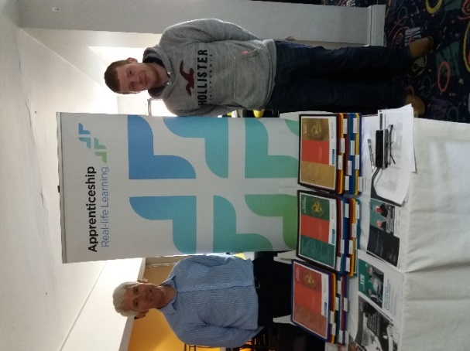
Outcomes:
We have successfully carried out 2 of the Options events to date with one more to be completed in October 18. We had a very successful number of NEETS who engaged with Options and who are also interested in the Foundations Programme. Many availed of the one to one career guidance and many made follow up appointments on the day.
Ballaghaderreen was successful with over 30 attending on the day, many were interested in the agencies who had participated on the day, some enrolled in the further education centre in Ballaghaderreen as a result of meeting the Coordinator on the day
Roscommon, which was the most recently completed, had 25 participants in attendance. However, this time we removed the category NEETS and opened it up to any age group. This day attracted all ages and many engaged with SICAP on the day and have had follow up appointments.
The selection of guest speakers was chosen well with an equal gender balance which reflected in the attendees.
Engagement with the target Groups in relation to the Options events.
In accordance with the CSO figures, it was established there was a high number of NEETS in disadvantaged areas. From this the Interagency/Task group contacted the DEASP in each of the disadvantaged areas in order to be able to reach out to this cohort and meet the data requirements. It was agreed that initially DEASP would contact anyone on the live register to invite them to the event days for Options.
Both RLP and GRETB used a separate marketing campaign also through social media and also through our Data base where we felt it would benefit this individual.
The options event days are a standalone day where the individual is invited to attend the day and receive any information they require, they were also given the opportunity to speak with SICAP staff to learn of their supports and to engage with GRETB for any further training. After the event, after seeking DATA consent, the individual was contacted to arrange a one to one appointment with SICAP.
In order to engage with the NEETS for Options we had a number of referrals from local agencies such as the Traveller Health Programme, DEASP and Foroige. However not relying on referrals alone ,the working group marketed the event through local agencies, DEASP, Social media platforms such as Facebook and Instagram, and it was also done through advertising leaflets and posters.
Core principles and approaches used in the engagement process, where there was careful selection to decide on the use of local champions/role models who could identify with our NEETS and relate to them on a personal level. The one to one career guidance counselling offered also was a beneficial engagement strategy to guide the individual and direct them to the correct path. The partnerships that were formed with the GRETB were vital to designing, financing and running the events. No one agency had the funding or staff capacity available to run the events on their own. Each of the partners brought expertise to the undertaking, and the support from the local agencies where they had information stands on the day.

The SICAP contribution in this particular area was a staff member who took on the role in order to organise the events from beginning to end which consisted of consulting with speakers, venue hire, catering, agenda’s, inviting and confirming local Agencies on the day, designing advertising material and distributing the material. SICAP funded the venue and catering cost also alongside this. The SICAP staff member has an educational background through teaching and therefore was involved with designing the events based on experience from working with Youths from disadvantaged areas and background’s. We also had a SICAP Coordinator who completed the MC for each event.
The core involvement with DEASP centred around the referrals and their supports through INTREO. The GRETB provided the one to one career guidance counselling and a vast array of education and training options with the inclusion of up to date information on the apprenticeship programmes on offer from the ETB’s. Other agencies such as MABS and CIC gave advice on the day on budgeting and the rights available to individuals. Local training Initiatives also attended on the days advertising their free training programmes and gave background information on the courses. We had employer engagement also from the areas such as in Ballaghaderreen and we also had the HR manager from Aurivo who gave a brief talk on his role and vacancies that existed within the company.
This work contributes to the horizontal principles of community development and equality by hosting the event in the local community and inviting agencies from the area to attend. This brings the communities together, by targeting the youth specifically within the community and allowing them to see the support network available to them and the venue suitability that allowed for all individuals, regardless of disabilities/ gender/ ethnic background etc, to attend. The equality of speakers where we carefully selected both male and female speakers showed how anyone regardless of gender has options in their career and personal lives.
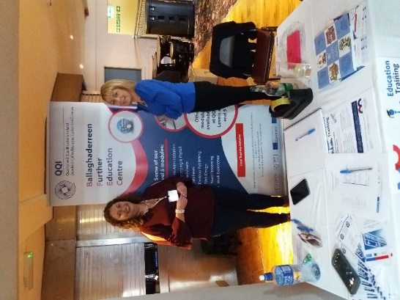
Collaboration:
As previously stated in the Introduction the need for the project/events were developed through a series of interagency meetings where it was established the need to engage with a cohort of NEETS aged 16-24 throughout the County of Roscommon. It came to our attention that in previous times training courses were organised yet, there was no engagement from this particular group. The partnership approach was vital to designing, financing and running the events. No one agency had the funding or staff capacity available to run these events solo and each of the partners brought expertise to the undertaking. RLP identified the need for the event and provided a staff member with education expertise and the GRETB provided the Adult Guidance Service.

RLP under their SICAP department brought expertise to the project. One individual staff member had an educational background and experience in engaging with the particular cohort of NEETS and also the SICAP Coordinator has an expertise background in Enterprise and development and employer engagement. Staff time, resources and funding were a huge beneficial factor to this project and it could not have happened without the SICAP support and contribution to these events.

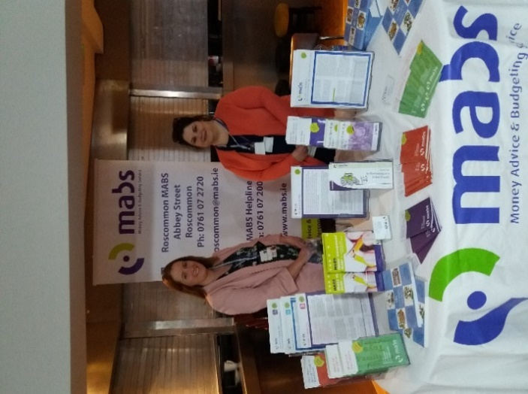
Our overall reflection of the events completed to date are we feel they were successful and beneficial to all involved. The attendance proved that in each area, the venues selected were all suitable and did not discriminate against anyone, locations were chosen to ensure that the area was covered well and allowed for outside town/villages to attend and lastly the speakers were the highlight as they were relatable and non-judgemental.
One addition we will make to the events will be to add the participation of more local employers & industry and to advertise a specific agenda that individuals could fully exploit the benefits of the day.
Working closely together with local agencies such as DEASP, GRETB and other local agencies, information sharing and the creation of opportunities for training and upskilling in a timely manner whilst offering flexibility to learners has shown the many benefits of collaboration and cooperation.

Appendix 1:
An overview of Foundations 2017
This is a brief summary of what ‘Foundations’ was in 2017 and how it leads to the work in 2018.
The Foundations Programme was intended to provide a mechanism to work with young people in a supportive way and help get them back on track, in terms of personal development, growth, confidence, developing a routine and being more active, supporting them to move closer to employment, by developing employability skills, and also to be an active contributor to society, acknowledge their social and civic responsibilities. The participants were provided with individualised support and mentoring with the aim of encouraging the participants to return back into mainstream employment, training or education. A long-term aim was also to invite the group to become more self-sufficient and less reliant on the social welfare system. In some cases, the goal was to engage participants into other community supports and the adult mental health system. Referrals were made in this area also.

There are varying reasons why each participant falls into the NEETS category which was the category we chose to base this pilot test around. There is a genuine explanation as to why they have fallen out of, or just don’t fit into, mainstream employment and training. It can be because of a mental health or addiction issue, learning needs, a traumatic life event or perhaps a poor educational experience.

As a direct result of this Programme:

Seventeen young people started the Foundations Programme in September 2017 and eleven completed the course.

• Eleven participants completed their QQI Level 3 Personal and Interpersonal Skills.
• Ten participants received their Drug Awareness Certificate.
• Ten participants completed their CVs and nine went on mock interviews.
• Nine participants passed their Driver Theory Test and obtained their provisional driving licenses.
• Nine participants received their Emergency First Aid Certificate.
• Nine participants received the Cardiac First Responder Certificate.
• Eight participants received their Manual Handling Certificate
• Six participants received their HACCP Certificate.

There were other significant outcomes related to the course beyond its completion and certification received. Participants are engaged with other courses and training opportunities in the region and into community and mental health supports. The participants are now more active in their own lives; they have a healthier outlook and are far more employable. The outcomes varied for each individual based on what they indicated on their personal action plans completed at the start of the training. Every participant benefited from attending in a lot of different ways and this was the purpose of the course from inception.

There were 412 unemployed people, looking for their first regular job as of April 2016. As of August 2017 there were 252 under 25 years signing for Jobseekers Benefit or Allowance. Of this, there were 146 were males and 106 females. 140 males were receiving Disability Allowance and 5 were receiving illness benefit that was under 25 years. 6 females were receiving illness benefit and 101 receiving disability allowance that was under 25 years. There are 75 Youth reach places in the County across both Centre’s in Ballaghaderreen and Roscommon. There are 39 areas classes as a disadvantaged area in the County.
Over the last number of years information sessions were held with DEASP, GRETB, RLP, and Options Sessions and motivation and mindset training was delivered. Every opportunity was provided to ensure the needs of Young People were identified during these sessions, together with other ongoing consultations for other plans including SICAP, LECP and Tusla. Findings from these consultations and the information sessions clearly outlined the need for the provision of a training programme that would engage the young people, whilst at the same time would be at a level relatable to them and provide structure and support to meet their other needs such as addiction and mental health, yet encouraging them to develop their skills and enhance their employability. In essence the need for wraparound supports were identified and Foundations was put in place to meet the needs, which were identified by service providers, and young people alike.

This course ran from the 19th of September to the 21st of December for 3 days a week. Tuesday, Wednesday and Thursday from 10-2pm. Participants arrived by a designated bus and had breakfast before beginning.

Appendix 2:

Foundations Evaluation/ Questionnaire

- Can you tell me where you are now i.e. Employment, training or other?

- What were the impacts that Foundations had on you?

- Do you feel doing foundations helped with where you are today?

- What supports helped you on the foundations programme?

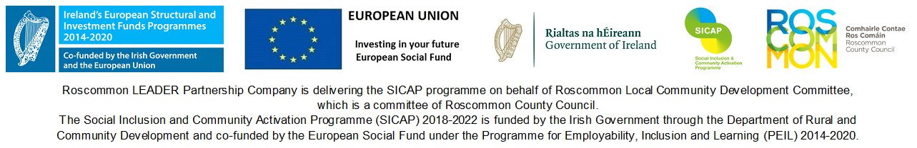
Appendix 3:
Social Inclusion and Community Activation Programme 2018 - 2022
Roscommon LEADER Partnership
Individual Data Consent Form
About SICAP
We Roscommon LEADER Partnership receive funding from the Department of Rural and Community Development, with co-funding from the European Social Fund as part of the Programme for Employability, Inclusion and Learning 2014-2020, to deliver the Social Inclusion and Community Activation Programme 2018 - 2022 (SICAP).
SICAP is a national programme which works with people to improve their outcomes in life. Pobal works with the Department of Rural and Community Development to help design and oversee the programme.
SICAP funding requires us to collect information on the people we register and support so we know more about them and the types of supports they need. We record when and how we helped you, for example if you went on a course or received any grants. We store this information on the SICAP database IRIS and on paper forms. You give this information by filling out the IRIS Individual Beneficiary Template.
The information you provide us with will be stored for seven years from when you leave SICAP in hard copy (paper forms) and on the IRIS computer database.

The Data
The information we record about you is used for five main purposes:
- To establish if you eligible for the programme.
- To review how we assisted you so we can provide you with the best possible tailored supports.
- To share your name and contact details with other service providers (e.g. ETB, Citizen Information Centre, Local Employment Service), as agreed with you in your Personal Action Plan, so we can make referrals and appointments on your behalf.
- To produce statistics which will help us plan and improve our services; so we can provide our funders with aggregated data to assist them in providing a better national service.
- Your data may be reviewed from time to time as part of a programme audit.
Some of the information we require is personal data such as your name and address, your phone number, your economic status, gender and age band etc. We need this in order to be able to contact you, to deliver a tailored service, and to know about the people who are engaging with SICAP. We will also be asking for your Personal Public Service Number (PPSN). This is voluntary and you do not have to provide it. The PPSN will help us and Pobal to track your progress over time, which will allow programme outcomes to be assessed.
We will be asking you for sensitive personal data. All sensitive data is voluntary and you do not have to provide this. Sensitive information is your ethnic/cultural background and if you have a disability. It is asked because it gives us more detail on which people are using SICAP and the extent to which different groups are receiving supports, and so we can monitor equality of access.
PPS Number | Initials to consent
I give my consent for my PPS Number to be recorded in order to allow Pobal and its agents to track my economic status over time, to evaluate the programme and improve government services.
Sensitive Personal Data | Initials to consent
I give my consent to record sensitive personal data about me.

Future Contact
Pobal, research bodies and/or agents of the Department may contact people who have registered with SICAP to get feedback about their experiences and to help them to evaluate SICAP. Only clients who have given their consent will be contacted. If you agree to b
e contacted, your contact details will be given to Pobal, research bodies and/or agents of the Department.
Future Contact | Initials to consent
I give my consent to be contacted for feedback on the SICAP services I received.
I understand that Roscommon LEADER Partnership will record my personal information in order to deliver and audit the programme. This may include referring me to another organisation or agency to provide a relevant service, which could involve passing on my contact details.
I have indicated whether I have given my consent to supply my PPSN, sensitive personal data and to be contacted for programme feedback, as shown by the boxes above.
I understand I can refuse or withdraw my consent to provide my PPSN, sensitive personal information and to be contacted for programme feedback if I wish and that this will not affect the service I receive.

Print Name:
Signature:
Date:
Your Rights
Under the Irish Data Protection Acts and the EU General Data Protection Regulation (GDPR) 2016 you have a right to request a copy of your personal information at any time. You can get this information by contacting us on 090 66 30252.
You can withdraw your consent to provide any of the information needed for SICAP and have your file deleted. You can do this by contacting us on 090 66 30252.
The Social Inclusion and Community Activation Programme (SICAP) 2018-2022 is funded by the Irish Government through the Department of Rural and Community Development and co-funded by the European Social Fund under the Programme for Employability, Inclusion and Learning (PEIL) 2014-2020.

