**Application Pack**

**Family Support / Community Development Worker**

Ballaghaderreen Family Resource Centre,

Market Street, Ballaghaderreen, Co Roscommon

# **Explanatory Notes for Candidates**

### Please read these instructions fully before completing Forms A1 and A2.

1. This Job Application Form is designed in such a way that all your personal details will be outlined on Form **A1** and will be used for administration purposes only. All specific information furnished by you relating to the post on offer will be outlined on Form **A2.**
2. Shortlisting will be based solely on the information furnished on Form **A2**; therefore, you should ensure that the information given is sufficiently comprehensive and relevant to the post on offer.
3. Read through the Application Form fully and then complete both Forms **A1** (one page) and **A2** (six pages). Handwritten Application Forms will not be accepted.
4. Keep a copy of your completed Job Application Form.
5. Applications will only be accepted on the official Job Application Form and should be received by **Monday 13th May at 1pm.** Late applications will not be considered.
6. Return the completed Application Form to the Recruitment Administrator:

[**recruitment@ridc.ie**](mailto:RECRUITMENT@RIDC.IE) **or Arigna Enterprise Centre, Arigna, Carrick-on Shannon P.O. Co. Roscommon N41 D2N8**

1. Application Forms sent by e-mail must be attached as a PDF. You must have time-stamped proof that the application form was sent and received to support any allegations of a loss or delay. This proof must be presented to the Recruitment Administrator within 72 hours of the closing date and time.
2. If posting a hard copy of the Application Form, a Post Office ‘Certificate of Posting’ must support any allegations of a loss or delay in the post. In the event of such a loss or delay, a photocopy of the completed application form and the ‘Certificate of Posting’ must be presented to the correspondence address above within 72 hours of the above closing date and time.
3. Do not forward any cover letter, Curriculum Vitae, Certificates or References with the Application Form.
4. Referees will only be contacted by the Centre with the permission of the candidate.
5. Canvassing will disqualify.
6. Personal Data provided by the candidate will be used for recruitment purposes only and will be protected in line with Ballaghaderreen Family Resource Centre Data Protection and Retention Policies.

|  |  |
| --- | --- |
| C:\Users\User1\AppData\Local\Packages\Microsoft.Office.Desktop_8wekyb3d8bbwe\AC\INetCache\Content.MSO\C386E0DD.tmp | **Application  Form**  **A1** |

|  |  |
| --- | --- |
| **CONFIDENTIAL** | **A\*\*** |

|  |
| --- |
| APPLICATION FOR POST OF **Family Support / Community Development Worker** |

|  |
| --- |
| **PERSONAL DETAILS** |
| Name: |
| Address: |
| Telephone Contact Number(s): |
| E-mail: |

|  |  |
| --- | --- |
| **REFERENCES** | |
| Give details of two referees, including your current or most recent work placement, who would support your application. | |
| In the event of a job offer, would you be willing to give **Ballaghaderreen Family Resource Centre** your permission to contact the two referees for a reference?  Yes  No | |
| **1. Current or last employment (Supervisor or Line Manager)** | |
| Name: | Organisation / Company: |
| Address: | |
| Email: | Telephone No: |

|  |  |  |
| --- | --- | --- |
| **2. Second Reference** | | |
| Name: | Organisation / Company: | |
| Address: | | |
| Email: | | Telephone No: |

|  |
| --- |
| **DECLARATION** |
| I certify that the information given in this application is accurate and complete to the best of my knowledge.  Signed: \_\_\_\_\_\_\_\_\_\_\_\_\_\_\_\_\_\_\_\_\_\_\_\_\_\_\_\_  Date: \_\_\_\_\_\_\_\_\_\_\_\_\_\_\_\_\_\_\_\_\_    Please note that the signing of this application form (forms A1 and A2) indicates that you have read the job description and any other information issued by the FRC and that you can comply with the requirements of the post. Any false statements may result in the application being declared invalid. |

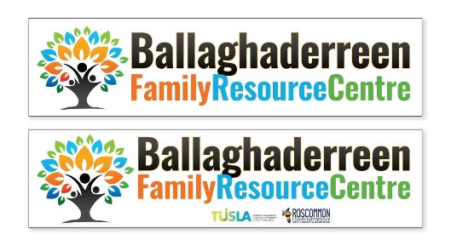

|  |  |  |  |
| --- | --- | --- | --- |
| |  |  | | --- | --- | | **CONFIDENTIAL** |  | | **Application  Form**  **A2** |

|  |
| --- |
| APPLICATION FOR POST OF **Family Support / Community Development Worker** |

|  |  |  |  |  |  |  |  |  |  |  |  |  |  |  |  |  |  |  |  |  |  |  |  |  |  |  |  |  |  |  |  |  |  |  |  |  |  |  |  |  |  |  |
| --- | --- | --- | --- | --- | --- | --- | --- | --- | --- | --- | --- | --- | --- | --- | --- | --- | --- | --- | --- | --- | --- | --- | --- | --- | --- | --- | --- | --- | --- | --- | --- | --- | --- | --- | --- | --- | --- | --- | --- | --- | --- | --- |
| |  |  | | --- | --- | | **EDUCATIONAL DETAILS**  Starting with the most recent, list all Certificates, Diplomas and/or Degrees and specify dates of attainment. Candidates called to interview will be asked to present verification of awards. | | | COURSE TITLE, QQI LEVEL & AWARDING BODY | YEAR COMPLETED | |  |  | |  |  | |  |  | |  |  |  |  |  | | --- | --- | | Starting with the most recent, list other non-accredited and/or relevant courses and specify dates of attainment. | | | COURSE TITLE & TRAINING ORGANISATION | YEAR COMPLETED | |  |  | |  |  | |  |  | |  |  | |  |  |  |  |  | | --- | --- | | **MEMBERSHIPS**  List all Professional Bodies, Voluntary and Community Sector Organisations, etc. of which you are or have been a member. If you played a specific role or undertook special responsibility within the organisation, please give details | | | NAME OF PROFESSIONAL BODY, VOLUNTARY &/or COMMUNITY ORGANISATION, ETC. | YEAR(S) OF MEMBERSHIP | |  |  | |  |  | |  |  | |  |  | |  |  |   **WORK EXPERIENCE** Starting with the most recent, give details of your work experience – include voluntary and unpaid work you feel may be relevant to this post | | |
| **Name of Current (or Last) Employer:** | |
| Indicate the Sector: Community and Voluntary Private Public | |
| Date of commencement: | Date of termination: |
| Outline reason(s) for leaving (if applicable): | |
| Position Title: | |
| Specify the type of work:  Paid  Voluntary  Hours per Week: | |
| Outline main tasks of the post: | |
| 1 | 2 |
| 3 | 4 |
| 5 | 6 |

|  |  |
| --- | --- |
| **Name of Previous Employer:** | |
| Indicate the Sector: Community and Voluntary Private Public | |
| Date of commencement: | Date of termination: |
| Outline reason(s) for leaving (if applicable): | |
| Position Title: | |
| Specify the type of work:  Paid  Voluntary  Hours per Week: | |
| Outline main tasks of the post: | |
| 1 | 2 |
| 3 | 4 |
| 5 | 6 |

|  |  |
| --- | --- |
| **Name of Previous Employer:** | |
| Indicate the Sector: Community and Voluntary Private Public | |
| Date of commencement: | Date of termination: |
| Outline reason(s) for leaving (if applicable): | |
| Position Title: | |
| Specify the type of work:  Paid  Voluntary  Hours per Week: | |
| Outline main tasks of the post: | |
| 1 | 2 |
| 3 | 4 |
| 5 | 6 |

|  |  |
| --- | --- |
| **Name of Previous Employer:** | |
| Indicate the Sector: Community and Voluntary Private Public | |
| Date of commencement: | Date of termination: |
| Outline reason(s) for leaving (if applicable): | |
| Position Title: | |
| Specify the type of work:  Paid  Voluntary  Hours per Week: | |
| Outline main tasks of the post: | |
| 1 | 2 |
| 3 | 4 |
| 5 | 6 |

|  |
| --- |
| **SUITABILITY FOR THE POST:**  Please answer all of the following questions. |

|  |
| --- |
| Under the headings below please outline your understanding, experience, skills and abilities in relation to the post of Family Support / Community Development Worker. In your answer please outline when, and for how many years, you were engaged in the relevant activity. Continue on a separate sheet if necessary. |
| **Providing family support in a community-based setting (including experience of organising community events)** |
| **Liaising / networking with community, voluntary and statutory agencies and organisations** |
| **Planning, developing and delivering programmes, activities and/or services to groups** |
| **Providing one-to-one supports directly to parents / families** |
| **SUITABILITY FOR THE POST (Continued):** |

|  |
| --- |
| **Delivering parent support programmes** |
| **Providing information to individuals and groups** |
| **Accessing funding and fundraising** |
| **Report writing** |
| **IT & Social Media Skills**  Please outline your competency level with the Microsoft Office Suite of applications. Please list the Social Media platforms that you can use. |

|  |
| --- |
| **SUITABILITY FOR THE POST (Continued):** |

|  |
| --- |
| **Experience of working with a voluntary board of directors** |
| **Knowledge / understanding of TUSLA’s Meitheal National Practice Model** |
| **Familiarity with Children First: National Guidance for the Protection and Welfare of Children** |

|  |
| --- |
| With reference to the Person Specification and Job Description - why do you think that you are particularly suitable for this position? |
|  |
|  |
|  |
|  |
|  |
|  |

|  |
| --- |
| Have you access to your own transport for work?  Yes  No |
| Do you have a clean full driving licence?  Yes  No |
| Can you provide a letter of indemnification from your insurer?  Yes  No |

|  |
| --- |
| Are there any legal restrictions on your availability to take up employment? If YES please give details. |
|  |

If appointed, when could you commence employment with Ballaghaderreen Family Resource Centre?



**Job description**

|  |  |
| --- | --- |
| **Job Title** | **Family Support / Community Development Worker** |
| **Overall Purpose**  **of the Job:** | To support and work with the Project Co-ordinator to support the project to implement its Work Plan.  To work in the community to determine the needs within the area, to build confidence and capacity of individuals, families and groups through supporting and developing relevant programmes and activities.  To network with service providers and other agencies and be actively involved in relevant interagency work. |

**Key Areas of Work**

**Community Based Family Support**

* Implement the five national outcomes developed for children and young people by Tusla
* Work collaboratively as part of the Meitheal Programme and other initiatives as developed
* Provide support and information to individuals and families attending Ballaghaderreen FRC
* Work as part of the team to deliver and develop relevant Family and Parent Supports
* Promote local target group involvement in the Centre
* Organise and facilitate training for the community and community groups.
* Identify factors leading to disadvantage in the area and work with the Voluntary Board of Directors and the Co-ordinator to raise awareness of these issues
* Deliver a range of family supports in the community in line with the Centre’s Workplan, including community events
* Ensure that the work of the Centre is in keeping with the aims and objectives of the Family Resource Centre Programme
* Raise the profile of the Centre
* Outreach the services of the FRC
* Provide support and information to individuals and groups that are disadvantaged
* Work with the relevant statutory and voluntary agencies and facilitate inter-agency co-operation to address the needs of the target group and families in the local community
* Work with the Co-ordinator to identify funding sources, make applications and liaise with funding agencies as required
* Facilitate networking at local and regional level as appropriate
* Work closely with the Co-ordinator to promote and support local voluntary and community activities that benefit the target groups of the Programme and address disadvantage and inequalities
* Participate in planning, review and evaluation of the work of the Centre

**Specific areas of work**

* Develop and support community initiatives that address the needs of local families in Ballaghaderreen and surrounding areas.

**General**

* Document the work on an on-going basis and prepare regular work / progress reports for the Voluntary Board of Directors and the Co-ordinator
* Participate in relevant training
* Any other tasks that may be assigned by the Project from time-to-time

**Other Relevant Information**

**Hours of Work**

* The post will be full-time – 35 hours per week
* The hours of work will be 9.00 to 13.00 hrs and 14.00 to 17.00 hrs, Monday to Friday unless otherwise agreed by the Voluntary Board of Directors. The Family Support / Community Development Worker will be expected to be flexible about evening and weekend work for which overtime will not be paid but time-off-in-lieu will be granted.
* A ten-month probation period will apply.

**Accountability**

The Family Support / Community Development Worker will report to, and be responsible to the Project Co-ordinator.

**Confidentiality**

The Family Support / Community Development Worker will observe confidentiality at all times in relation to Centre business.

**Salary**

The salary will be commensurate with qualifications and experience.

**Holidays**

You are entitled to 25 days annual leave (pro-rata for part-time positions).

**Garda Vetting**

The position is subject to the completion of a satisfactory Garda Vetting process.

**Person Specification for**

**Family Support / Community Development Worker**

|  |  |  |  |
| --- | --- | --- | --- |
| **Job Title:** | **Family Support / Community Development Worker** | | |
| **Name of Employer:** | **Ballaghaderreen** **Family Resource Centre** | | |
|  | This Person Specification is a description of the skills, knowledge and experience required for the position. | | |
| **Essential** | |  | **Desirable** | |
| * A 3rd level qualification in Family Support Practice, Community Development or a related discipline – Level 7+ * 2 years’ paid experience, post qualification, of providing family support in a community-based setting, including: * Experience of organising community events * Liaising/networking skills and ability to work with a range of community, voluntary and statutory agencies * Experience of planning, developing and delivering programmes, activities and/or services to groups * Experience of providing supports directly to parents / families * Experience delivering parent support programmes * Experience of providing information and support to individuals and groups * Group facilitation skills * Excellent report writing skills * Ability to compile funding applications and source funding opportunities * IT & social media skills * Excellent communication and presentation skills * Access to own transport for work. | |  | * Experience of working with a voluntary board of directors * Familiarity with Meitheal (TUSLA’s National Practice Model) * Familiarity with Children First Guidance | |

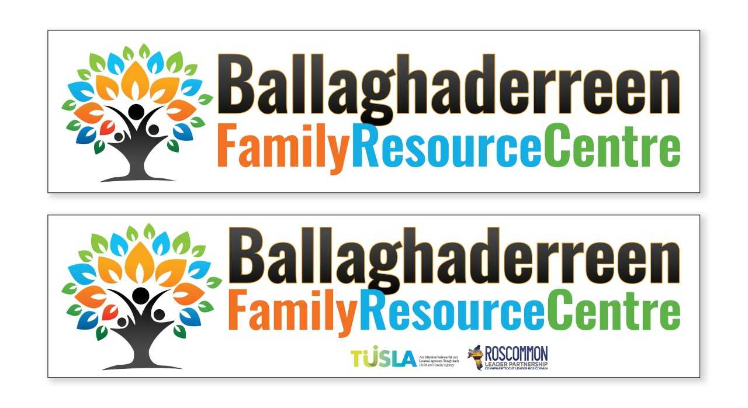

Applications are invited for the post of:

**Family Support / Community Development Worker**

The Family Support / Community Development Worker will work closely with the Project Co-ordinator to support the project to implement its Work Plan.

The ideal candidate should have:

* A relevant third level qualification – minimum Level 7 (e.g. Family Support Practice or Community Development);
* A minimum of 2 years’ paid work experience, post qualification, of providing family support in a community-based setting, including experience of:
  + organising community events;
  + liaising / networking with community, voluntary and statutory agencies;
  + delivering programmes, activities and/or services to groups;
  + providing one-to-one supports directly to parents/families;
  + delivering parent support programmes;
  + providing information and support to individuals and groups;
* Proven experience in accessing funding;
* Excellent IT, social media and report writing skills;
* Access to own transport and a full clean driving license.

This position is 35 hours per week.

**Application form and full Job Description is attached below**

*Please note:* ***Applications will only be accepted on the official Application Form*** *and CVs will not be accepted. Please submit your completed Application Form to recruitment@ridc.ie*

**Closing date and time for receipt of applications is Monday 13th May at 1pm**

Short listing will apply.

Interviews will take place on the 20th May 2019.

Satisfactory references, evidence of qualification and Garda Vetting will be required.

This project is an equal opportunities employer.

This position is funded by TUSLA Child and Family Agency.

